AIOPS used Kafka messaging service and Spark because Spark is suitable for both real time and batch processing applications below we mentioned architecure

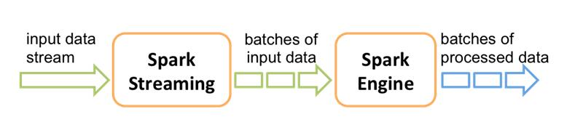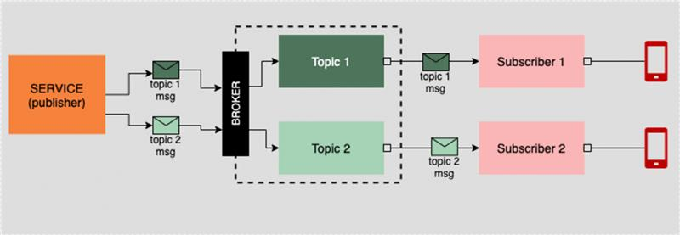

Developed an automatic solution to responding and triggering the corresponding bot for JVM Crash usecase & ServiceNow tickets. Predict the issue before it occurs by analyzing & comparing historical trends and applying the event Correlation mechanism using the DL LSTM method and identified which event is actionable events so for that take real-time data from Splunk/elk. That data is given as input to Mlmodel. To analyze this kind of huge application data using Kafka messaging service pipeline, for that we need to start kafka broker(kafkacluster), zookeeper, zookeeper is the central management system and by using kafka application , integration layer team send whatever logs are generated from APPD application they pushed those data into kafka topic they named event queue topic and AIENGINE team submit Spark Submit command and submit Spark Application to the cluster in cli where our project setup is present in that command we mentioned
integration layer topic name and ml engine take data from that topic and start spark application we call sparkcontext that is the entry point for spark functionality by using that we communicated with cluster and we create new RDD and We pass the Spark context along with the batch duration 0.1 seconds and then Using the native Spark Streaming Kafka capabilities, we use the streaming context from above to connect to our Kafka cluster and we started spark application, by using pysprk collect method retrieved all the elements and then by using spark parse and clean the data and for that data processing we done data transformations and from that new RDD created and removed duplicate events, parentid and duplicacy mapping ,removed the events which is 60 sec crossed, and then called ml model for which event is actionable events and integration layer team stored real time events into elk from that our model take input as past 60 sec data as input and that is passed to ML model and then by using MLintelligence we can get response like confidencescore, correlation , which event is actionable events which one we take it as priority and then by using spark foreachRDD method Apply a function to each RDD in this DStream and at last we sent our json response to the another kafka topic named aiml_response_queue from that integration layer received it.

Ml model sample response
{'Parent_ID': 'Null', 'ID': '118741', 'event_type': 'ERROR', 'event_type_key': 'Business Transaction Error', 'event_message': '[Error] - HTTP error code : 404', 'problem type': 'Generic', 'event-corelation': 'Yes', 'confidance score': '1.0', 'duplicacy': 'No', 'workflow': 'AiOps_Test_Queue', 'parameter': 'Null'}

.
Sample spark submit command
/spark/spark-2.3.2-bin-hadoop2.7/bin/spark-submit --packages org.apache.spark:spark-streaming-kafka-0-8_2.11:2.1.0 filename.py 0.0.0.0:9092 event_queue

